Format 6
Symbiosis Institute of Technology, Pune
Evaluation Plan
Department: Department of Artificial Intelligence & Machine Learning | Batch: 2023-27
Course Name: Principles of Economics (0701260401)
Credit: 2 | Year /Sem: 2024-2025/ IV
Name of the faculty member: Pratibha Sharma

Sr. No. | Component | CO | Max marks | Weight | Tentative date
1 | MCQ | CO1 | 15 | 100% | 12 February
2 | Unit Test | CO2, CO3 | 20 | 100% | 17-22 March
3 | Case Study | CO4 | 15 | 100% | 13 April

Sign of the faculty member
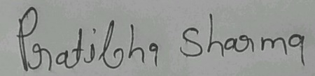
Pratibha Sharma

